* The dataset had 4 tables called locations, people, products and sales. And when we first went for creating our first chart showcasing country wise sales, we encountered our first challenge. The challenge is that even though we have only 6 countries, the chart gives us one extra column called ‘Blank’ it happened because in our original dataset, the Geography column had countries which are having multiple spaces before their name which gave birth to this blank-problem. 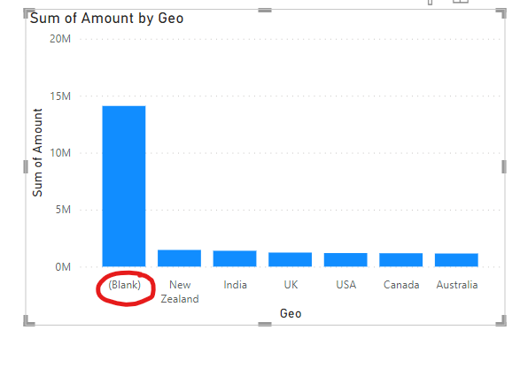 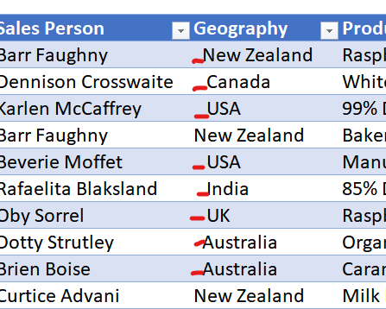
* To solve this problem, either we can change/clean it inside the original dataset or clean the data at PowerBI level. To change it at PowerBI level, go to home-> transform data, it opens the power query editor now select that column give right click-> transform-> trim. (It sets a rule inside powerBI that without changing the original dataset, whenever there is a dataset which is having extra spaces, it’ll trim those spaces.
* The next step we wanted to see teamwise sales, we used donut chart but this time also there are few members which comes under ‘Blank’ team. We clicked on that part and shown that this group had fair share of sales in all the countries so we need to do something about this blank-problem. For seeing which are the people under different teams, we selected the Blank group from donut and used table from viz and gave the sales person as ip column.

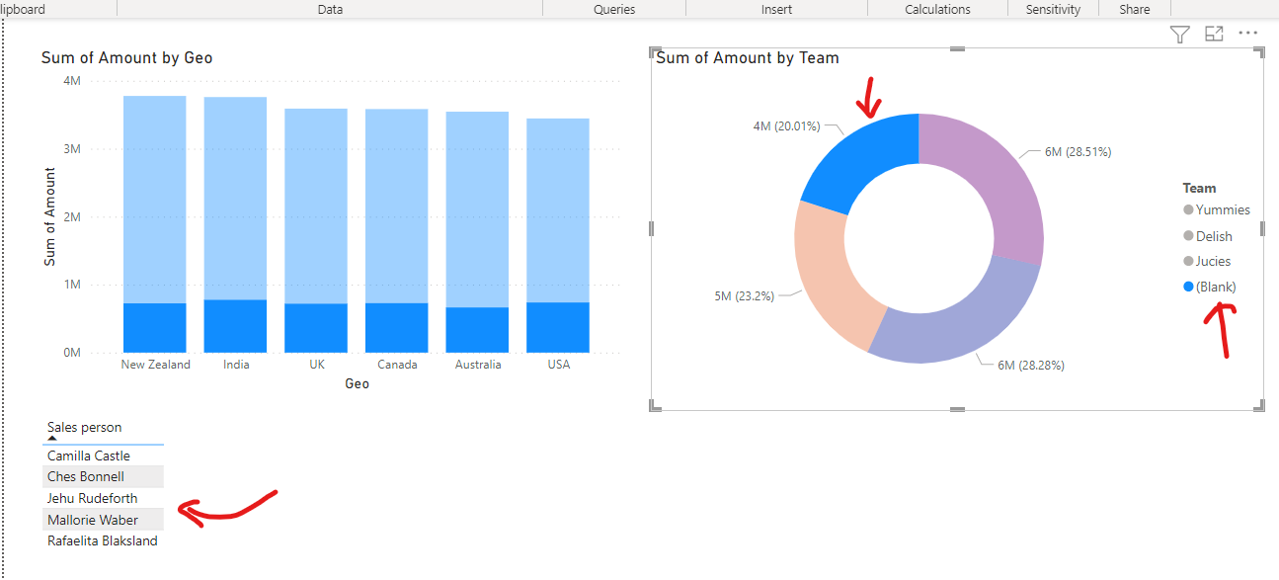

* Now to solve this, we again go to transform data and replace these nulls with let’s say ‘Unique’. Again, it’ll create a rule for the future that whenever in this Team col there is a null, replace it with ‘Unique’ name. (Remember that power query is case sensitive)
* Next, we wanted to see sales person wise total sale. We’re going to use tables as there are a lot of sales persons. And also, one slicer so as to select them as per their teams. And for seeing the total sales by the specific sales person, we’re going to use DAX (data analysis expression) for defining a measure for summing the sales amount for specific sales persons. To create that measure, go to sales and right click-> new measure-> then write Total Amount= sum(sales[Amount]). And then select that measure for the tables vizualisation.
* Then we did some visualization editing for this added table and slicers. In Amount per Box measure, added the conditional formatting also as a data bar in order for it to look professional.
* As per the given dataset, the product have only 3 categories, and we want to see the category wise sales. For that we just added one col chart, and given category as x-axis and Sum of Amount as Y axis. Now, if we click on any specific sales person, we’re gonna see his/her category wise sales.   
  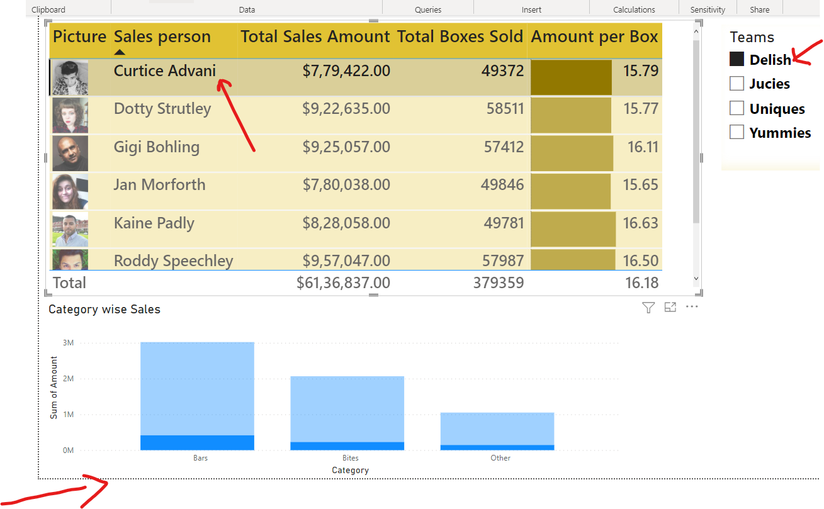
* The above thing shows like, that specific person has how much of sales (proportion of sales) of different categories in comparison to total of his/her team, but we want that if we click on any specific sales person, we just wanted to see his data alone. This needs a little bit of customisation on the interactive behaviour of the Power Bi. For this challenge, we need to select the main table -> Format ->Edit Interactions -> (It will give you three options 1. Filter, 2. Highlight, 3. No-interaction or none) Click on Filter
* Use the idea on the first page of the report that, create one measure and add it with the sales person table as if the sales amount is less that specific amount, give a category and of it is more that the specific amount give it a category. So, like that …
* Part-3 Now we are going to see Trend Analysis and Forecasting in Power BI
* For this trend analysis and forecasting, we used one line chart (forecasting is not there in area chart and stacked area chart so we used line chart only) and used Sales Amount and Date for ‘Time varying sales amount’ then Total Customer measure and Date for ‘Time varying customer count’.

For forecasting select the graph and go to -> third option of analysis -> switch on Forecast and set it according to your need as we did here for 3 months only.

* Now our report is ready, but I wanted to add one more thing in the first page and that is when the total sales done by the salesperson is >= $ 9lac then it’ll be rated as 5 star, if it is <= $8lac and $9 lac then 4 star and if it is < $ 8lac then 3 star. We created a new measure called salesperson rating and used if else nesting in order to get the desired ratings. Additionally, I used conditional formatting of type ‘icon’ in order to salesperson to be rated as per the rule that 5 star means green, 4 star means amber and 3 star means red light. This way salesperson looks to be visually rated. It adds visual goodness to the report.